##### 9008 Meisner Road, Casco, MI 48064 / [www.ourstjameschurch.org/](http://www.ourstjameschurch.org/)

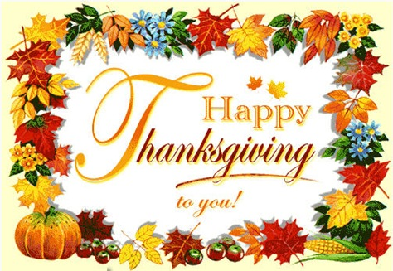

Greetings to all

For many years now, November has been a spiritually significant month for me. There are many events and church remembrances that fill me with a sense of gratitude and an appreciation for God’s grace in my life. I have often said, “I have not gotten all that I deserve…. And for that I am grateful”.

The month always begins with All Saints Day, a day that allows me to remember and honor all those on whose shoulders I stand, both past and present. There have been so many people that have touched my life in so many wonderful ways. I truly enjoy thinking about them while on my journey, knowing they travel with me fills me with grace and humility.

About grace, this is the month that causes me to be intentionally focused on gratitude. As always, I quote my old friend Dwight who used to regularly remind me that “gratitude is the aristocrat of attitudes”. I could not agree more. Gratitude for me is where joy and contentment are found. He would also regularly remind me that I could not get what I wanted until I wanted what I got. I don’t necessary think that was about wanting lives hardships or the possibility of the future accumulation of “stuff” so much as a reminder that happiness and contentment are found inside rather than outside of us. And once we wanted what we had (gratitude) we would not find it so necessary to have the “stuff”.

And then there is Thanksgiving. Thanksgiving is one of my favorite holidays. Perhaps it is because the marketing world and big box stores have not figured out how to make a ton of money on it yet. Even though it makes me crazy that some stores want to be open Thanksgiving night to take peoples Christmas money I am even happier that some stores who tried it the last couple years have decided to stay closed this year.

In these challenging times, it can seem difficult at times to find things to be grateful for.

Contents

News from Pastor Ken 1

Pastor Ken News Cont. 2

Upcoming Events 2

Prayers Needed 3

Outreach Ministry 3

Discretionary Fund 3

Birthdays 4

Military List 4

Worship Ministry 4

Earthly Gift Ministry 4

Roof Collection Meter 4

Bottle Can Collection 4

Thanksgiving Poem 5

Thanksgiving Brunch 6

St. John’s Fun and Game Night 6

Christmas Shoeboxes 7 & 8

Ministers Needed 8

Kid’s Page 9

Altar Care 10

Communion Servers 10

Ushers/Greeters 10

Liturgist Readers 10

Scripture Readings 10

# News from Pastor Ken

https://www.facebook.com/St-James-United-Church-of-Christ-10150090210425008/



Newsletter

November 2018

Volume 3, Issue 10

The purpose of a newsletter is to provide specialized information to a targeted audience. A school newsletter can be a great way to develop a strong relationship with parents.

First choose a short title for your newsletter— something like "School News," or “Back to School.” As you choose the title, also take time to think about the newsletter’s theme. What important messages do you want to send parents and families?

Next, establish how much time and money you can spend on your newsletter. These factors will help determine how frequently you publish the newsletter and its length.

Use the body of your school newsletter to keep parents apprised of major assignments and class events, as well as any of school district news. Also share news for specific grade levels, and tell parents about upcoming events, new faculty, and school policies.

## Dear Parents

St. James United Church of Christ

Therefore, here is my annual invitation for you to participate in one of my more meaningful Thanksgiving practices. Every year, sometime around Thanksgiving I write a list of 4-6 things that I am TRULY grateful for (I’m not talking about grateful for chocolate ice cream grateful, though I am, but what I am TRULY grateful for). As a side note, if you can only think of one or two- think harder, if you want to write 20-30, then think harder and prioritize the top 4-6. Then I put the list somewhere I can see it regularly, on the refrigerator, near the computer monitor, bathroom mirror, you get the idea, as a reminder. Sometimes when life gets challenging, it can be easy to forget. It is helpful for me to have a little written reminder of God’s many blessings in my life.

If you are one who finds themselves bubbling over with gratitude, or at least have some sense of it. I encourage you to lend a hand, write a note, make a call or drop an email to someone who you know who could use a little reminder (by the way, that’s just about everybody) that one of lives blessings is that we have people in our life that simply care. Sometimes it is the smallest gestures that make the biggest difference.

I am also looking forward to my Advent time of reflection and preparation. It begins the first Sunday in December this year. I invite you to participate with me in some small way. It is about a daily reminder of my relationship with God. Truly a time of prayer and meditation. I invite you to join me in remembering that despite what the major retailers would have us believe, Advent is not Christmas. It is a time of intentional and internal preparation for the spiritual gifts of Christmas. More on this next month.

You have touched my life in significant ways and I give thanks daily for you. I wish you a Thanksgiving Season filled with grace and gratitude that lasts throughout the year. Remember that whoever you are and wherever you are on life’s journey, you are held in God’s unconditional love, boundless mercy, unending grace and that there is a place for you here.

Take care and be well, Peace

Ken

And I thought you might find this interesting…. **Definitions of Gratitude**

**Webster:** Synonyms and Antonyms of GRATITUDE

acknowledgment of having received something good from another <accept these flowers as a token of my *gratitude*>

**Synonyms** [appreciation](http://www.merriam-webster.com/dictionary/appreciation), [appreciativeness](http://www.merriam-webster.com/dictionary/appreciativeness), [gratefulness](http://www.merriam-webster.com/dictionary/gratefulness), [gratitude](http://www.merriam-webster.com/dictionary/gratitude),

[thankfulness](http://www.merriam-webster.com/dictionary/thankfulness)

**Related Words:** [thanksgiving](http://www.merriam-webster.com/dictionary/thanksgiving); [gratification](http://www.merriam-webster.com/dictionary/gratification), [indebtedness](http://www.merriam-webster.com/dictionary/indebtedness), [satisfaction](http://www.merriam-webster.com/dictionary/satisfaction); [acknowledgment](http://www.merriam-webster.com/dictionary/acknowledgment) (*or*acknowledgement), [recognition](http://www.merriam-webster.com/dictionary/recognition), [tribute](http://www.merriam-webster.com/dictionary/tribute)

**Christian Bible:** Thankfulness, Thanksgiving

**Gratitude in Islam**

Gratitude in Islam is one of the most fundamental aspects of this religion. A Muslim is not merely one cognizant of the fact that the creator of the universe is one and is responsible for everything he has in this life i.e. his consciousness, his health, his family, his sanity and his wealth but also realizes that it is his obligation to express gratitude to his lord.

**Gratitude in Judaism**

The Hebrew term for gratitude literally means “recognizing the good”. Practicing gratitude recognizes the good that is already yours.

## Upcoming Events

* November 4 – Communion Sunday

Discretionary Fund

Memorial Day Celebration / All Saints Day

* November 10 – St. John’s Fun and Games Night 6-9pm
* November 13 – Council Meeting 7pm
* November 17- Euchre 6:30pm
* November 18 – Communion Sunday 9am

Thanksgiving Brunch at Riveria in Marine City– 12pm

* November 25 – Hanging of the Green & Pot Luck supper 2pm

**Pastor Ken Newsletter Continued**

**Page 2 of 10**

George

David

Deborah

Lynn

Johnnie

Peggy

Marion

Joanne

Claudette

Lorene

St. Augustine Richmond Food Pantry

**Immediate needs are:** Macaroni & cheese, boxed potatoes, canned pork & beans/baked beans, assorted canned fruit (pears, pineapple, etc.), one-pound bag of white rice, saltine crackers, peanut butter, jams/jellies assorted flavors, pancake

mix/syrup, instant oatmeal, after school snacks, condiments (mustard, ketchup, salad dressings, mayo).

**The Discretionary Fund**

**November 4, 2018**

Did you know this fund is utilized to aid with rent, utilities, medical supplies, food and transportation to doctors, etc.?

This is generated from the loose change collected the first Sunday of each month. Please empty your pockets and change purses that day to meet the needs of our church and community.

**B-WARM NEEDS**

Cleaning supplies: Toilet bowl cleaner, bleach, laundry soap, dish washing detergent, bathroom cleansers.

Men’s clothing: sweatshirts, coats, and jackets.

**Blue Water Area Rescue Mission** **– B-WARM**

Karen Marie

Sue

Jackie

Kathy

Rich

Maraleen

Clark Russell

Tony

Baby Charlee

Trudy

**Outreach Ministry**

**Kids in Distress**

**Current needs** are as follows:

High chair, crib, twin sheets and fall and winter clothes for both boys and girls in all sizes.

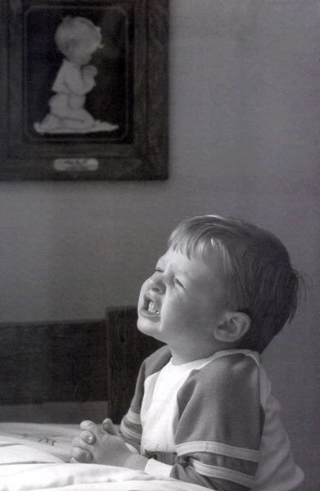

Prayers for….

**Page 3 of 10**

The Financial Goal for October is $5,750.00 and contributions so far this month were $2205.00.  With the last two months and this month looking like the goal not being meet, St. James is fortunate to have raised $3,563.70 at the Chili Cook-Off and additional funds of $340.40 at the Foxfire Fixin's and $343.00 at the monthly Euchre Event.  Thanks to everyone who supported these events to meet our financial obligations.

**Page 4 of 10**

|  |
| --- |
| 1 - LeAnne Bandlow |
| 4 - Gary Teltow |
| 8 - Joel Szymanski |
| 9 - John Lyszczyk |
| 13 - Julie Wendt |
| 15 - Matt LaDuke |
| 15 - Dan Riley |
| 20 - Jennifer Uppleger |
| 21 - Bradley Strunk |
| 23 - Audrey DeFer |
| 23 - Lee Mahnke |

**Earthly Gifts**

## Happy Birthdays in November

**Roof Collection**

To donate just mark your regular envelope the amount that should go to the roof or use the small envelope in the pew indicating your name or envelope number or just leave blank if you don't want to be recognized just put roof on the envelope.  Thanks once again for your support of St. James.  Only $15,396.38 to go.

**Worship Ministry**

**Volunteers Needed**

**Please sign-up**

Please consider signing up for the ministries of Usher/Greeter, Liturgists

and Altar Care. Sign-up sheets for each are provided in the basement.

**Page 4 of 9**



**Military Prayer List**

I will be including a list in the newsletter of our men and women in the military, to acknowledge those who serve and to pray for their safety. Please submit your love one’s, family member or friend’s name, rank and branch of service to Roberta Fisher to be placed on the list.

**Bottle / Can Collection**

We are collecting empty and clean bottles and cans with a deposit on them to support our Christian Education Program. Please bring them to church, there is a box in the basement, back room, by the door for them.

**Thanksgiving Poem**

Page 5 of 10



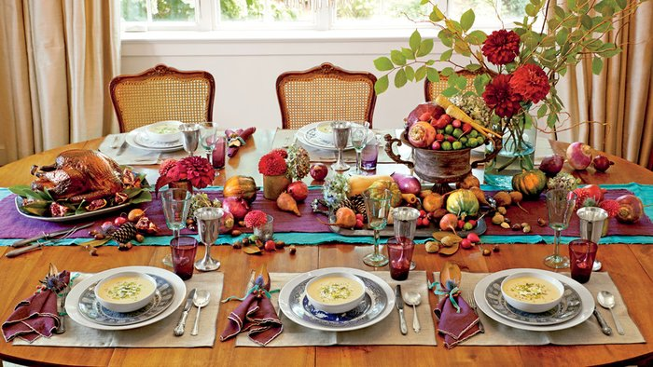

**Page 6 of 10**

**Thanksgiving Brunch**

**Sunday, November 18th, 2018 at 12:00pm**

**Riviera Restaurant**

**475 S Water St, Marine City, MI 48039**

**Come share a meal together - Members of St. James and St. Johns to celebrate Thanksgiving and all that we are grateful for.**

***Adults - $8.95, Seniors - $7.95, Kids - $5.95 and children under 10 are free***

**St. John’s Fun and Games Night**

The Mary Martha Guild is sponsoring a Fun and Games Night on Saturday, November 10 from 6-9 pm in the Fellowship Room at St. John’s.  Everyone, young and old, is invited. Bring along your favorite game or we’ll have some here for you…Euchre, Yahtzee, Bunco, Trivial Pursuit, just to name a few.  Snacks and beverages are provided.  The cost is $5 per person or $8 per couple or family.  Sign-up sheets are on the counter in the Fellowship Room.  See you there!!

**Page 7 of 10**

**Christmas Shoeboxes and**

**Local Community Charities**

We collect the below items for boys and girls from the age of 2 to 14 years old. Our goal is to fill 100 boxes/tote bags by November 11, 2018 without running out of items. **November 2018 collection is Socks, hats, gloves and toys.** Items accepted anytime are: hat, gloves, socks, toys, school supplies (pens, pencils, erasers, pencil sharpeners, small note books, glue, crayons), hygiene items (soap, washcloths, combs, toothpaste, toothbrushes, floss), headbands, barrettes and bows, socks (All Men, Women and Children – All sizes **(No children small size)**.

**I have included a list of what has already been collected, so you can easily see what is still needed to fill 100 boxes/tote bags in November.**

|  |  |
| --- | --- |
| **Christmas Shoe Box Collection** | |
|  |  |
| Dental Floss | 611 |
| Toothbrushes | 110 |
| Soap | 13 |
| Washcloths | 55 |
| Combs | 30 |
| Blankets | 5 |
| Socks | 4 |
| Hats | 51 |
|  |  |
| **Gloves** |  |
| Size 2 - 4 | 3 |
| Size 5 - 9 | 22 |
| Size 10 - 14 | 19 |
| **Total Gloves** | 41 |
|  |  |
| Scarf | 1 |
| Notebooks | 16 |
| Pens | 55 |
| Pencils | 98 |
| Erasers | 127 |
| Crayons | 28 |
| Colored Pencil Set | 9 |
| Highlighter | 12 |
| Glue | 26 |
|  |  |
| **Toys** |  |
| For 2 - 4 | 49 |
| Girls 5 - 9 | 7 |
| Boys 5 - 9 | 46 |
| For 10 - 14 | 1 |
| Either sex 5-14 | 9 |
| **Total Toys** | 112 |
|  |  |
| **Totes** |  |
| Done | 65 |
| To Finish | 48 |
| **Total Totes** | 113 |
|  |  |
|  |  |
| No longer need |  |

**Page 8 of 10**

**Ministry Needing Helpers!!!!!**

Members are needed to take the items received for donation to B-Warm, Kids-In-Distress and Richmond Food Pantry (St. Augustine). As you see the boxes/tubs getting full please feel free to help in this ministry by taking the items to the designated places. **Call first**, to make sure they are open for deliveries.

B-Warm Kids-In-Distress Richmond Food Pantry

1920 24th St 1114 S 7th St St. Augustine

Port Huron, MI 48060 St. Clair, MI 48079 68035 Main St

[(810) 956-0768](https://www.google.com/search?q=blue+water+area+rescue+mission+port+huron+mi&rlz=1C1CHBD_enUS725US725&oq=blue+water+area+rescue+mission&aqs=chrome.1.69i57j0.24248j0j7&sourceid=chrome&ie=UTF-8) [(810) 326-4505](https://www.google.com/search?rlz=1C1CHBD_enUS725US725&ei=j-5pW5X5EJCwsAW8gi4&q=kids+in+distress&oq=kids+in+distress&gs_l=psy-ab.3..0l2.106654.110108.0.110732.16.10.0.6.6.0.127.1111.1j9.10.0....0...1c.1.64.psy-ab..0.16.1140...0i131k1j0i67k1.0.DlX_ayFsvYg) Richmond, Mi 48062

[(586) 727-5215](https://www.google.com/search?rlz=1C1CHBD_enUS725US725&ei=_-5pW9i8EarU0gLBo7uABg&q=st.%20augustine%20richmond%2C%20mi&oq=st.+augustine+richmond%2C+mi&gs_l=psy-ab.3..0l2j0i22i30k1l8.104519.111156.0.111685.26.19.0.7.7.0.167.2177.0j19.19.0....0...1c.1.64.psy-ab..0.26.2232...0i131k1j0i67k1j0i131i67k1.0.WxeagXRGxKw&npsic=0&rflfq=1&rlha=0&rllag=42801870,-82749132,24&tbm=lcl&rldimm=12359400108849307256&ved=2ahUKEwj9q6KO09vcAhWAFzQIHWs6CAEQvS4wAHoECAQQEw&rldoc=1&tbs=lrf:!2m1!1e2!3sIAE,lf:1,lf_ui:2)

**Kid’s Page**

**Page 9 of 10**

**Color picture per instructions below.**

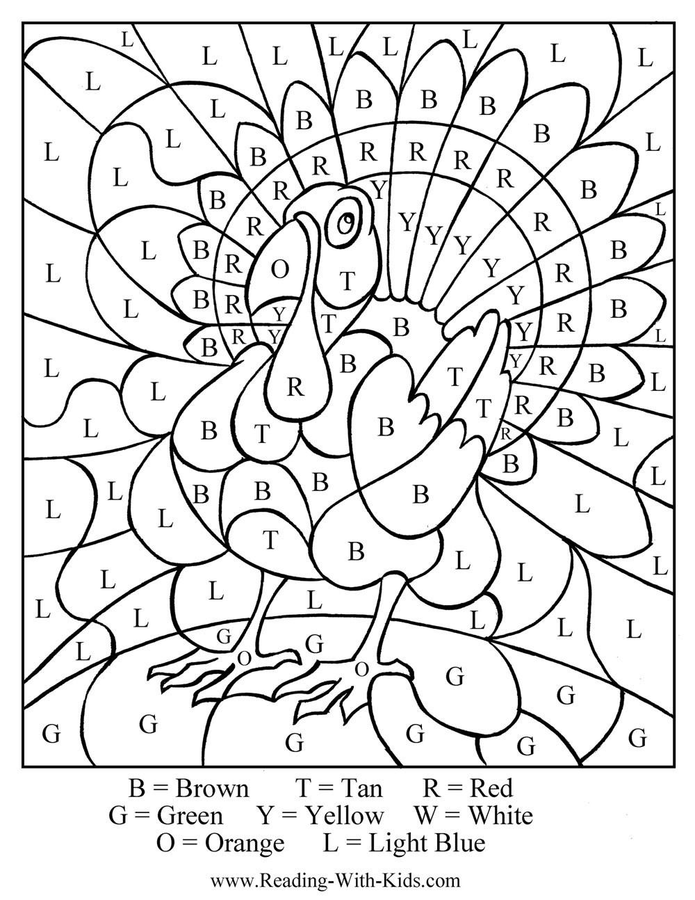

**Page 10 of 10**

**Altar Care**

**Communion Servers**

November – Open

**Preparer:** Shelley Kargula

**Communion Servers:** Shelley Kargula & Bev Kulman

**Ushers & Greeters**

**Liturgists**

November 4 - Open

November 11 – Open

November 18 - Open

November 25 – Open

November 4 - Open

November 11 – Open

November 18 - Open

November 25 – Open

## Scripture Readings for November

**Sunday, November 4 Sunday, November 11**

**Thirty-first Sunday in Ordinary Time Thirty-second Sunday in Ordinary Time**

Ruth 1: 1-8 Ruth 3: 1-5; 4: 13-17

Ps 146 or Deut 6: 1-9 Ps 127 or1 Kings 17: 8-16

Ps 119: 1-8 Ps 146

Heb 9: 11-14 Heb 9:24-28

Mk 12: 28-34 Mk 12: 38-44

**Wherever You go Risk & Restoration**

**Sunday, November 18 Sunday, November 25**

**Thirty-third Sunday in Ordinary Time Reign of Christ**

1 Sam 1: 4-20 2 Sam 23: 1-7

1 Sam 2: 1-10 or Daniel 12: 1-3 Ps 132: 1-12, (13-18) or Daniel 7: 9-10,

Heb 10: 11-14, (15-18), 19-25 13-14

Mk 13: 1-8 Ps 93

**Praise the Holy One** Rev 1: 4b-8

Jn 18: 33-37

**A Wise Reign**

**St. James United Church of Christ**

**9008 Meisner Road**

**Casco, MI 48064**

**Phone:**

(586) 727--1623

**Fax:**

(586) 27-0833

**E-mail:**

kgadd@ourstjameschurch.org

We’re on the Web!

**Ourstjameschurch.org**

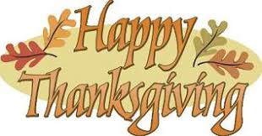

NOVEMBER

NEWSLETTER

